ADS
iLogic Rules
Description of iLogic rules

ADS
7/8/2013

Contents
1. VIRTUAL COMPONENTS 3
2. Work Features 9
3. Update copied properties. 11
4. Save PDF 12
5. Save DXF 13
6. Scale of first view in titleblock 14

- VIRTUAL COMPONENTS

Issue:
You have a number of standard Virtual parts that you find yourself adding over and over. You'd like to have the ability to add them based on a predefined list.

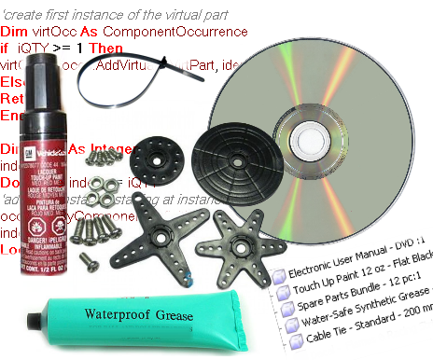

Solution:
Here is an example iLogic rule that will read a *.txt file and present the contents to the user in an input box list. The user is then asked to enter a quantity for the virtual part, and then the virtual part occurrences are added to the assembly. If one or more occurrences of the virtual part exist in the assembly, the iLogic rule deletes them and just adds back the total number needed.

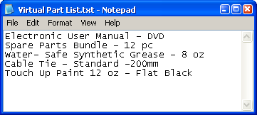
An example text file list

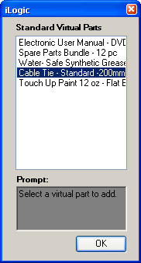
The list presented to the user in an input list box.

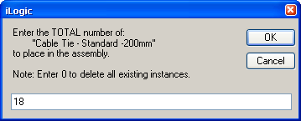
The input box presented to the user to set the quantity.

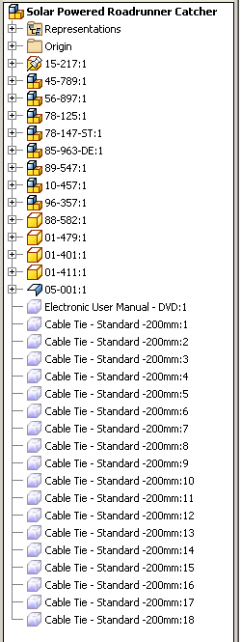
The virtual parts added to the assembly.

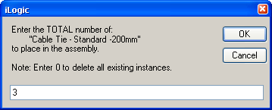
Adjusting the quantity.

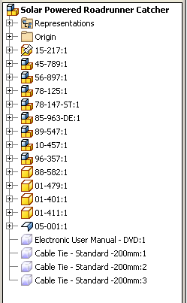
The iLogic rule deletes the original 18 occurrences and just adds back the number specified.
Here is the example iLogic rule:
(special thanks to Brian Ekins for the code he posted at this link.)

Imports System.IO
'open and read a text file
Dim oRead As New StreamReader("U:\iLogic examples\Virtual Part List.txt")
Dim sLine As String = ""
Dim MyArrayList As New ArrayList

'build list from text file
Do
sLine = oRead.ReadLine()
If Not sLine Is Nothing Then
MyArrayList.Add(sLine)
End If
Loop Until sLine Is Nothing
oRead.Close()

'get user input from list
sVirtPart = InputListBox("Select a virtual part to add.", _
MyArrayList, MyArrayList.Item(0), "iLogic", "Standard Virtual Parts")

'check for empty input
'in the case where the user
'cancels out of the input box
If sVirtPart = "" Then
Return 'end rule
Else
End if

'get quantity from user
iQTY = InputBox("Enter the TOTAL number of:" _
& vblf & " ''" & sVirtPart & "''" _
& vblf & "to place in the assembly." _
& vblf & vblf & "Note: Enter 0 to delete all existing instances.", "iLogic", "1")

'check for empty input
'in the case where the user
'cancels out of the input box
If iQTY = "" Then
Return 'end rule
Else
End if

'define assembly
Dim asmDoc As AssemblyDocument
asmDoc = ThisApplication.ActiveDocument
'define assembly Component Definition
Dim oAsmCompDef As AssemblyComponentDefinition
oAsmCompDef = ThisApplication.ActiveDocument.ComponentDefinition

'Iterate through all of the occurrences in the assembly
Dim asmOcc As ComponentOccurrence
For Each asmOcc In oAsmCompDef.Occurrences
'get name of occurence only (sees only everything left of the colon)
Dim oOcc As Object
oOcc = asmOcc.name.Split(":")(0)
'look at only virtual components
If TypeOf asmOcc.Definition Is VirtualComponentDefinition Then
'compare name selected from list to the
'existing virtual parts
If oOcc = sVirtPart Then
'delete existing virtual parts if name matches
asmOcc.delete
Else
End if
Else
End If
Next

Dim occs As ComponentOccurrences
occs = asmDoc.ComponentDefinition.Occurrences

Dim identity As Matrix
identity = ThisApplication.TransientGeometry.CreateMatrix

'create first instance of the virtual part
Dim virtOcc As ComponentOccurrence
if iQTY >= 1 Then
virtOcc = occs.AddVirtual(sVirtPart, identity)
Else
Return
End if

'add next instance starting at instance2 (if applicable)
Dim index As Integer
index = 2
Do While index <= iQTY
occs.AddByComponentDefinition(virtOcc.Definition, identity)
index += 1
Loop

- Work Features

Issue:
You have other members of your design team that do not remember to turn off work features at the part level or sub-assembly level when they are done working with those files. As a result file previews and view representations get messed up. You'd like to have a quick way to toggle all of the work features off. Can this be done with iLogic?
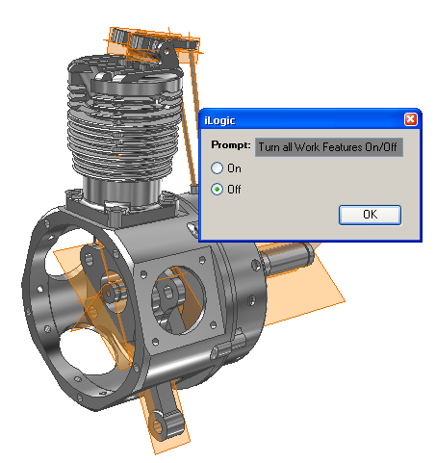

Solution:
You can use this example iLogic rule to toggle all work features on or off.
'catch and skip errors
On Error Resume Next
'define the active assembly
Dim oAssyDoc As AssemblyDocument
oAssyDoc = ThisApplication.ActiveDocument

'get user input as True or False
wfBoolean = InputRadioBox("Turn all Work Features On/Off", "On", "Off", False, "iLogic")

'Check all referenced docs
Dim oDoc As Inventor.Document
For Each oDoc In oAssyDoc.AllReferencedDocuments
'set work plane visibility
For Each oWorkPlane In oDoc.ComponentDefinition.WorkPlanes
oWorkPlane.Visible = wfBoolean
Next
'set work axis visibility
For Each oWorkAxis In oDoc.ComponentDefinition.WorkAxes
oWorkAxis.Visible = wfBoolean
Next
'set work point visibility
For Each oWorkPoint In oDoc.ComponentDefinition.WorkPoints
oWorkPoint.Visible = wfBoolean
Next
Next
'upate the files
InventorVb.DocumentUpdate()

- Update copied properties.

Issue:
You have a lot of drawings that need update copied iproperties of the model (updates copied iproperties of the model in the drawing).
Solution:
Use the code to force the drawing to update copied properties from the model. Can be used with Code Injector to do a batch of drawings at a time.
File to be used: UpdateProps.iLogicVb

- Save PDF

Issue:
You have to export one or many drawings at a time to pdf.
Solution:
Use the code to export current drawing to pdf. It creates (if didn't exist) a folder called DXF on same path as drawing (needs saving first) in which a pdfwith the filename being "Drawing_filename + Drawing_description + Revision". Can be used with Code Injector to do a batch of drawings at a time.
Make SURE that the drawing is saved otherwise the path of the folder and pdf will be on root drive.

File to be used: SavePDF.txt

- Save DXF

Issue:
You have to export one or many drawings at a time to dxf.
Solution:
Use the code to export current drawing to dxf. It creates (if didn't exist) a folder called DXF on same path as drawing (needs saving first) in which a dxf with the filename being "Drawing_filename + Drawing_description + Revision". Can be used with Code Injector to do a batch of drawings at a time.
Make SURE that the drawing is saved otherwise the path of the folder and dxf will be on root drive.

File to be used: SaveDXF.txt

- Scale of first view in titleblock

In order to have the scale show up and update automatically in the titleblock, do the following.
- Edit your title block definition and add a Text item with the type Prompted Entry
- This text should contain <Scale>
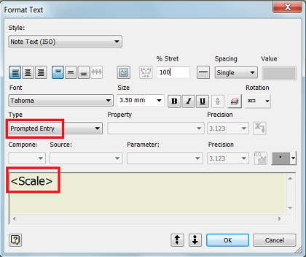
After you add this, Inventor will prompt you for a Scale value whenever you add the title block to a sheet.
The same happens when you add a new sheet with the title block to the drawing or when you start a new drawing using a template where you have applied this solution.
- When it prompts you, just leave the value blank
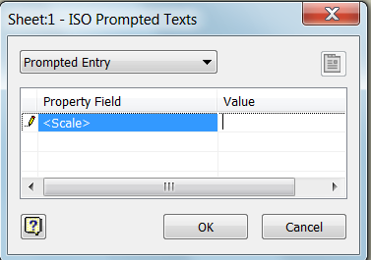
- Then add the rule in text bellow to the drawing
File to be used: Prompted_Scale.txt
- Add the rule to the trigger “Before Save Document”
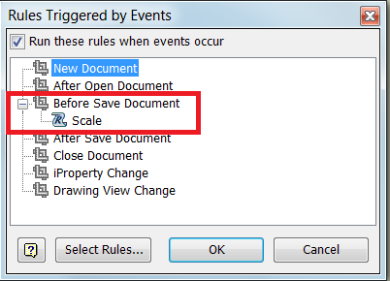
After that, on every sheet in the drawing, you will get the scale value from the first view on that sheet in the title block when you save the file.

